Lê Thanh Phương Nam

ITITWE19025

Report Lab 1 TMC

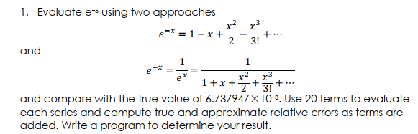

Code:

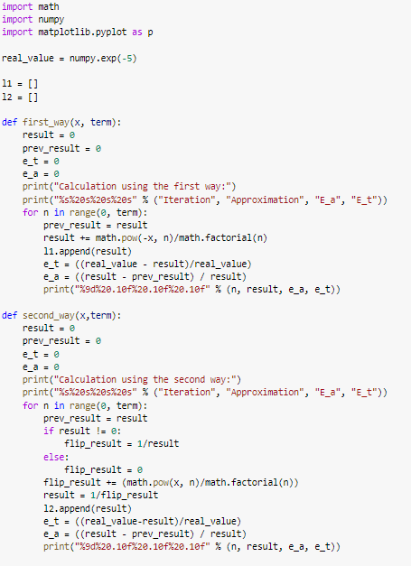

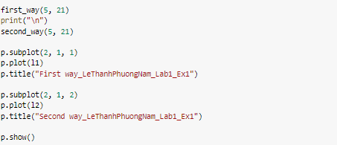

Step:

S1: import library math, numpy, matplotlib

S2: create a value e-5

S3: create 2 arrays for 2 methods

S4: create the function to solve the method 1:

1. With 2 inputs:value x, and number of term.
2. Output is n, result, error approximate, error true value

S5: Create the function to slove the mothod 2:

1. With 2 input: value x, and number of term
2. Output is n, result, error , error approximate, error true value

S6: Print and Plot

Result:

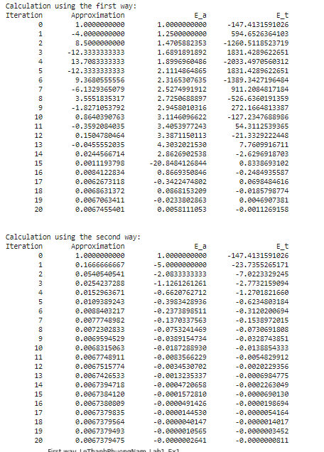

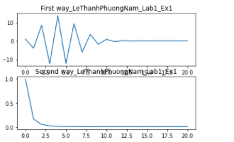

Compare the result:

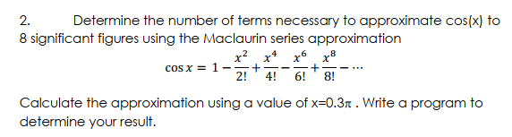

Step:

S1: Declare Libs

S2: define function print

S3: define x= 0.3pi, error_threshold = 10-8, true value

Code:

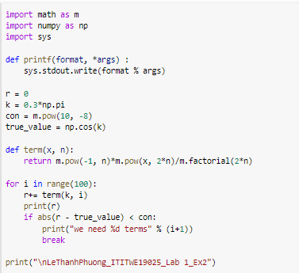

Result:

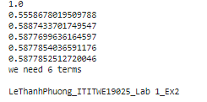

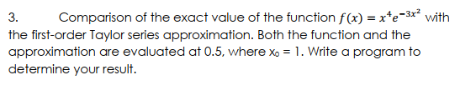

Code:

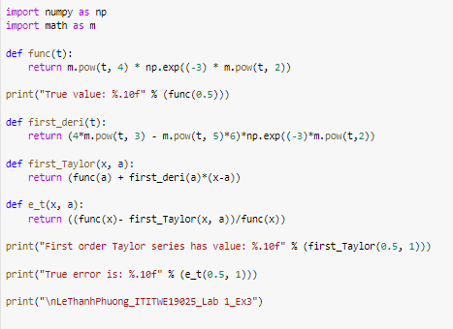

Result:

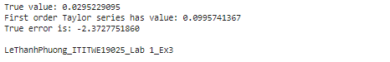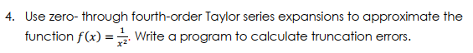

Code:

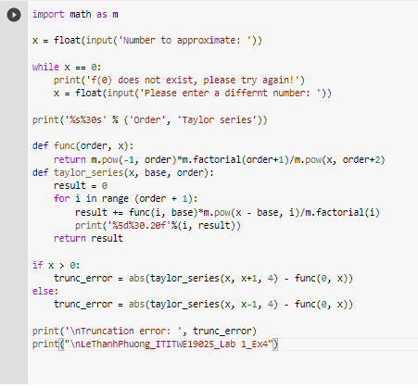

Result:

